Batch: C4-1 Roll No.: 16010124216

Experiment / assignment / tutorial No

Grade: AA / AB / BB / BC / CC / CD /DD

Signature of the Staff In-charge with date

|  |
| --- |
| **TITLE:** Write a program to demonstrate exception handling and file handling mechanism in Python   1. **AIM**: 1) Write a program to demonstrate exception handling mechanism in Python   2) Write a program to demonstrate File handling mechanism in Python  **OUTCOME:** Students will be able to  **CO1:** Formulate a problem statement and develop the logic (algorithm/flowchart) for its solution.  **CO5:** Apply the concept of exception handling and file handling in Python. |
|  |

To demonstrate how exceptions can be used to improve our programs' robustness, reliability, and maintainability by handling unexpected errors effectively also demonstrate the File Handling mechanism in Python.

**______________________________________________________________________**

**Resource Needed: Python IDE**

**______________________________________________________________________**

**Books/ Journals/ Websites referred:**

1. Reema Thareja, *Python Programming: Using Problem-Solving Approach*, Oxford University Press, First Edition 2017, India
2. Sheetal Taneja and Naveen Kumar, *Python Programming: A modular Approach*, Pearson India, Second Edition 2018, India
3. https://www.geeksforgeeks.org/python-strings/?ref=lbp

**______________________________________________________________________**

**Theory:**

**Exception Handling in Python:**

## What is Exception?

An exception is an event, which occurs during the execution of a program that disrupts the normal flow of the program's instructions. In general, when a Python script encounters a situation that it cannot cope with, it raises an exception. An exception is a Python object that represents an error.

When a Python script raises an exception, it must either handle the exception immediately otherwise it terminates and quits.

Built-in Exceptions

Commonly occurring exceptions are usually defined in the compiler/interpreter. These are called built-in exceptions. Python’s standard library is an extensive collection of built-in exceptions that deal with commonly occurring errors (exceptions) by providing standardized solutions for such errors. When any built-in exception occurs, the appropriate exception handler code displays the reason along with the raised exception name. The programmer then has to take appropriate action to handle it. Some of the commonly occurring built-in exceptions that can be raised in Python are explained below

Following is the list of common exception classes found in Python:

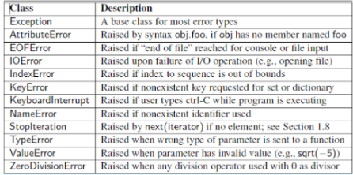

## Handling an exception

If you have some suspicious code that may raise an exception, you can defend your program by placing the suspicious code in a **try:** block. After the try: block, include an **except:** statement, followed by a block of code that handles the problem as elegantly as possible.

**The try-except else block:**

**Syntax:**

try:

You do your operations here;

except ExceptionI:

If there is ExceptionI, then execute this block

else:

If there is no Exception, then execute this block

Here are few important points about the above-mentioned syntax:

* A single try statement can have multiple except statements. This is useful when the try block contains statements that may throw different types of exceptions.
* You can also provide a generic except clause, which handles any exception.
* After the except clause(s), you can include an else-clause. The code in the else-block executes if the code in the try: block does not raise an exception.
* The else-block is a good place for code that does not need the try: block's protection.

### Example:

This example opens a file, writes content in the, file and comes out gracefully because there is no problem at all

try:

fh = open("testfile", "w")

fh.write("This is my test file for exception handling!!")

except IOError:

print "Error: can\'t find file or read data"

else:

print "Written content in the file successfully"

fh.close()

This produces the following result:

Written content in the file successfully

### Example:

This example tries to open a file where you do not have write permission, so it raises an exception

try:

fh = open("testfile", "r")

fh.write("This is my test file for exception handling!!")

except IOError:

print "Error: can\'t find file or read data"

else:

print "Written content in the file successfully"

This produces the following result:

Error: can't find file or read data

## The Except Clause with No Exceptions:

You can also use the except statement with no exceptions defined as follows:

try:

You do your operations here;

…………………..

except:

If there is any exception, then execute this block

………………………….

else

If there is no exception, then execute this block

…………………………….

This kind of a **try-except** statement catches all the exceptions that occur. Using this kind of try-except statement is not considered a good programming practice though, because it catches all exceptions but does not make the programmer identify the root cause of the problem that may occur.

## The Except Clause with Multiple Exceptions:

You can also use the same except statement to handle multiple exceptions as follows:

try:

You do your operations here;

......................

except(Exception1[, Exception2[,...ExceptionN]]]):

If there is any exception from the given exception list,

then execute this block.

......................

else:

If there is no exception then execute this block.

## The try-finally Clause:

You can use a **finally:** block along with a **try:** block. The finally block is a place to put any code that must execute, whether the try-block raised an exception or not. The syntax of the try-finally statement is this

try:

You do your operations here;

......................

Due to any exception, this may be skipped.

finally:

This would always be executed.

......................

You cannot use else clause as well along with a finally clause.

### Example

try:

fh = open("testfile", "w")

fh.write("This is my test file for exception handling!!")

finally:

print "Error: can\'t find file or read data"

If you do not have permission to open the file in writing mode, then this will produce the following result

Error: can't find file or read data

The same example can be written more cleanly as follows:

try:

fh = open("testfile", "w")

try:

fh.write("This is my test file for exception handling!!")

finally:

print "Going to close the file"

fh.close()

except IOError:

print "Error: can\'t find file or read data"

When an exception is thrown in the try block, the execution immediately passes to the finally block. After all the statements in the finally block are executed, the exception is raised again and is handled in the except statements if present in the next higher layer of the try-except statement.

## The argument of an Exception:

An exception can have an argument, which is a value that gives additional information about the problem. The contents of the argument vary by exception. You capture an exception's argument by supplying a variable in the except clause as follows −

try:

You do your operations here;

......................

except ExceptionType, Argument:

You can print value of Argument here...

If you write the code to handle a single exception, you can have a variable follow the name of the exception in the except statement. If you are trapping multiple exceptions, you can have a variable follow the tuple of the exception.

This variable receives the value of the exception mostly containing the cause of the exception. The variable can receive a single value or multiple values in the form of a tuple. This tuple usually contains the error string, the error number, and an error location.

### Example

Following is an example for a single exception

# Define a function here.

def temp_convert(var):

try:

return int(var)

except ValueError, Argument:

print "The argument does not contain numbers\n", Argument

# Call above function here.

temp_convert("xyz");

This produces the following result:

The argument does not contain numbers

invalid literal for int() with base 10: 'xyz'

## Raising an Exceptions:

You can raise exceptions in several ways by using the raise statement. The general syntax for the **raise** statement is as follows.

### Syntax:

raise [Exception [, args [, traceback]]]

Here, Exception is the type of exception (for example, NameError) and argument is a value for the exception argument. The argument is optional; if not supplied, the exception argument is None.

The final argument, traceback, is also optional (and rarely used in practice), and if present, is the traceback object used for the exception.

### Example

An exception can be a string, a class or an object. Most of the exceptions that the Python core raises are classes, with an argument that is an instance of the class. Defining new exceptions is quite easy and can be done as follows:

def functionName( level ):

if level < 1:

raise "Invalid level!", level

# The code below to this would not be executed

# if we raise the exception

**Note:** In order to catch an exception, an "except" clause must refer to the same exception thrown either class object or simple string. For example, to capture above exception, we must write the except clause as follows −

try:

Business Logic here...

except "Invalid level!":

Exception handling here...

else:

Rest of the code here...

## User-Defined Exceptions

Python also allows you to create your own exceptions by deriving classes from the standard built-in exceptions.

Here is an example related to RuntimeError. Here, a class is created that is subclassed from RuntimeError. This is useful when you need to display more specific information when an exception is caught.

In the try block, the user-defined exception is raised and caught in the except block. The variable e is used to create an instance of the class Networkerror.

class Networkerror(RuntimeError):

def __init__(self, arg):

self.args = arg

So once you defined above class, you can raise the exception as follows −

try:

raise Networkerror("Bad hostname")

except Networkerror e:

print e.args

**File Handling in Python**

Till now, we were taking the input from the console and writing it back to the console to interact with the user.

Sometimes, it is not enough to only display the data on the console. The data to be displayed may be very large, and only a limited amount of data can be displayed on the console since the memory is volatile, it is impossible to recover the programmatically generated data again and again.

The file handling plays an important role when the data needs to be stored permanently in the file. A file is a named location on a disk to store related information. We can access the stored information (non-volatile) after the program termination.

The file-handling implementation is slightly lengthy or complicated in the other programming languages, but it is easier and shorter in Python.

**File operation can be done in the following order:**

Open a file

Read or write - Performing operation

Close the file

**Opening a file:**

Python provides an open() function that accepts two arguments, file name and access mode in which the file is accessed. The function returns a file object which can be used to perform various operations like reading, writing, etc.

**Syntax:**

file object = open(<file-name>, <access-mode>, <buffering>)

The files can be accessed using various modes like read, write, or append. The following are the details about the access mode to open a file.

|  |  |  |
| --- | --- | --- |
| **SN** | **Access mode** | **Description** |
| 1 | r | It opens the file to read-only mode. The file pointer exists at the beginning. The file is by default open in this mode if no access mode is passed. |
| 2 | rb | It opens the file to read-only in binary format. The file pointer exists at the beginning of the file. |
| 3 | r+ | It opens the file to read and write both. The file pointer exists at the beginning of the file. |
| 4 | rb+ | It opens the file to read and write both in binary format. The file pointer exists at the beginning of the file. |
| 5 | w | It opens the file to write only. It overwrites the file if previously exists or creates a new one if no file exists with the same name. The file pointer exists at the beginning of the file. |
| 6 | wb | It opens the file to write only in binary format. It overwrites the file if it exists previously or creates a new one if no file exists. The file pointer exists at the beginning of the file. |
| 7 | w+ | It opens the file to write and read both. It is different from r+ in the sense that it overwrites the previous file if one exists whereas r+ doesn't overwrite the previously written file. It creates a new file if no file exists. The file pointer exists at the beginning of the file. |
| 8 | wb+ | It opens the file to write and read both in binary format. The file pointer exists at the beginning of the file. |
| 9 | a | It opens the file in the append mode. The file pointer exists at the end of the previously written file if exists any. It creates a new file if no file exists with the same name. |
| 10 | ab | It opens the file in the append mode in binary format. The pointer exists at the end of the previously written file. It creates a new file in binary format if no file exists with the same name. |
| 11 | a+ | It opens a file to append and read both. The file pointer remains at the end of the file if a file exists. It creates a new file if no file exists with the same name. |
| 12 | ab+ | It opens a file to append and read both in binary format. The file pointer remains at the end of the file. |

**Example:**

#opens the file file.txt in read mode

fileptr = open("file.txt","r")

if fileptr:

print("file is opened successfully")

**Output:**

<class '_io.TextIOWrapper'>

file is opened successfullyProblem Definition:

In the above code, we have passed the filename as a first argument and opened file in read mode as we mentioned r as the second argument. The fileptr holds the file object and if the file is opened successfully, it will execute the print statement.

**The close() method:**

Once all the operations are done on the file, we must close it through our Python script using the close() method. Any unwritten information gets destroyed once the close() method is called on a file object.

We can perform any operation on the file externally using the file system which is the currently opened in Python; hence it is good practice to close the file once all the operations are done.

The syntax to use the close() method is given below.

**Syntax:**

fileobject.close()

**Example:**

try:

fileptr = open("file.txt")

# perform file operations

finally:

fileptr.close()

**Reading and Writing Files**

The file object provides a set of access methods to make our lives easier. We would see how to use read() and write() methods to read and write files.

**The write() Method**

The write() method writes any string to an open file. It is important to note that Python strings can have binary data and not just text.

The write() method does not add a newline character ('\n') to the end of the string

**Syntax:**

fileObject.write(string)

**Example:**

# Open a file

fo = open("foo.txt", "wb")

fo.write( "Python is a great language.\nYeah its great!!\n")

# Close opend file

fo.close()

The above method would create foo.txt file and would write given content in that file and finally it would close that file. If you would open this file, it would have following content.

**Output:**

Python is a great language.

Yeah its great!!

**The read() Method**

The read() method reads a string from an open file. It is important to note that Python strings can have binary data. apart from text data.

**Syntax:**

fileObject.read([count])

Here, passed parameter is the number of bytes to be read from the opened file. This method starts reading from the beginning of the file and if count is missing, then it tries to read as much as possible, maybe until the end of file.

**Example:**

# Open a file

fo = open("foo.txt", "r+")

str = fo.read(10);

print "Read String is : ", str

# Close opend file

fo.close()

**Output**

Read String is : Python is

**File Positions**

The tell() method tells you the current position within the file; in other words, the next read or write will occur at that many bytes from the beginning of the file.

The seek(offset[, from]) method changes the current file position. The offset argument indicates the number of bytes to be moved. The from argument specifies the reference position from where the bytes are to be moved.

If from is set to 0, it means use the beginning of the file as the reference position and 1 means use the current position as the reference position and if it is set to 2 then the end of the file would be taken as the reference position.

**Example:**

# Open a file

fo = open("foo.txt", "r+")

str = fo.read(10)

print "Read String is : ", str

# Check current position

position = fo.tell()

print "Current file position : ", position

# Reposition pointer at the beginning once again

position = fo.seek(0, 0);

str = fo.read(10)

print "Again read String is : ", str

# Close opend file

fo.close()

**Renaming and Deleting Files**

Python os module provides methods that help you perform file-processing operations, such as renaming and deleting files.

To use this module you need to import it first and then you can call any related functions.

**The rename() Method**

The rename() method takes two arguments, the current filename and the new filename.

**Syntax:**

os.rename(current_file_name, new_file_name)

**Example:**

Following is the example to rename an existing file test1.txt −

import os

# Rename a file from test1.txt to test2.txt

os.rename( "test1.txt", "test2.txt" )

**The remove() Method**

You can use the remove() method to delete files by supplying the name of the file to be deleted as the argument.

**Syntax:**

os.remove(file_name)

**Example:**

Following is the example of deleting an existing file test2.txt −

import os

# Delete file test2.txt

os.remove("text2.txt")

**Problem Definition:**

1. Write a program in which we prompt users to enter personal details like name and surname, which should be strings, age should be an integer, and height and weight should be float. Whenever the user enters input of the incorrect type, keep prompting the user for the same value until it is entered correctly. Give the user sensible feedback
2. Write a program to create a file employeedetails.txt" which stores the Employee details by adding their Employee Id, Name, and Department into it using the following format:

EmpId Name Department

1601001 Abc Computer

1601003 Xyz IT

Obtain the details for EmpId from the user.

**Books/ Journals/ Websites referred:**

1. Reema Thareja, Python Programming: Using Problem-Solving Approach, Oxford University Press, First Edition 2017, India
2. Sheetal Taneja and Naveen Kumar, Python Programming: A modular Approach, Pearson India, Second Edition 2018, India

**Implementation details:**

Q1

*def* get_string(*prompt*):

    while True:

        try:

            value = input(prompt)

            if value.isalpha():

                return value

            else:

                raise *ValueError*("Please enter only alphabetic characters.")

        except *ValueError* as e:

            print(e)

*def* get_integer(*prompt*):

    while True:

        try:

            value = *int*(input(prompt))

            return value

        except *ValueError*:

            print("Invalid age. Please enter a valid integer for age.")

*def* get_float(*prompt*, *field_name*):

    while True:

        try:

            value = *float*(input(prompt))

            return value

        except *ValueError*:

            print(*f*"Invalid {field_name}. Please enter a valid number for {field_name}.")

name = get_string("Enter your name: ")

surname = get_string("Enter your surname: ")

age = get_integer("Enter your age: ")

height = get_float("Enter your height: ", "height")

weight = get_float("Enter your weight: ", "weight")

Q2

with open("employeedetails.txt", "x") as f:

    f.write("EmpId           Name          Department\n 1601001     Abc          Computer\n 1601003     Xyz           IT\n")

**Output(s):**

Q1  
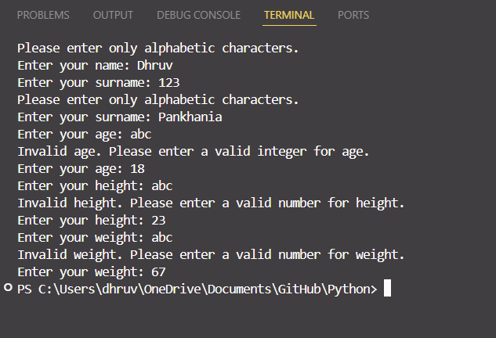

Q2

**Conclusion:**

In the development process, robust error handling and effective file handling are critical for creating reliable and user-friendly applications. Error handling ensures that our programs can gracefully manage unexpected situations, like invalid inputs or missing files, allowing for informative feedback to users and preventing crashes.

File handling, is crucial for managing data persistence and retrieval. Whether reading from or writing to files, ensuring proper file access and error management contributes to data integrity and smooth operation.

**Post Lab Questions:**

1. Write a program that takes a list of numbers as input from the user and calculates their average. If the list is empty, raise a custom exception EmptyListError with an appropriate error message.  
   *class* EmptyListError(*Exception*):

*def* __init__(*self*, *message*="No numbers entered. The list is empty."):

*self*.message = message

*super*().__init__(*self*.message)

try:

    a = *str*(input("Enter a List a Number(Space Separated): "))

    if not a:

        raise EmptyListError()

    a = *list*(map(*float*, a.split()))

    avg = 0

    for i in a:

        avg = sum(a)/len(a)

    print(*f*"The average of the given numbers is {avg}")

except EmptyListError as e:

    print(e)

1. What is the purpose of the "finally" block in a try-except-finally block?

The purpose of the finally block in a try-except-finally structure is to ensure that a specific block of code runs regardless of whether an exception occurred or not. The code inside the finally block will execute after the try block, even if an exception is raised and handled in the except block. This is commonly used for tasks like releasing resources that need to happen no matter what.

1. Virtual lab on File Operation: <https://python-iitk.vlabs.ac.in/exp/file-operators/index.html>   
     
   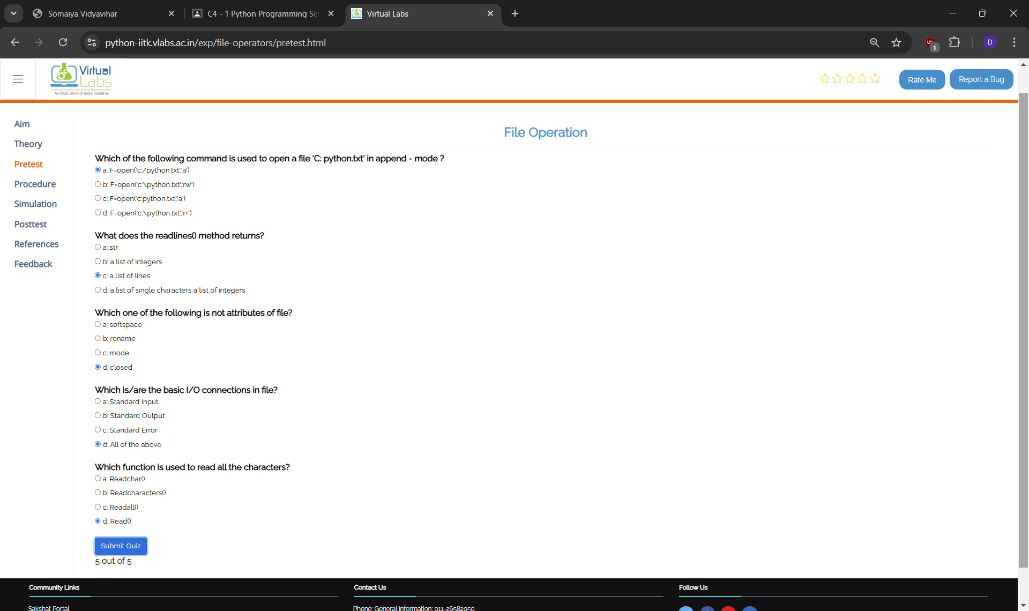

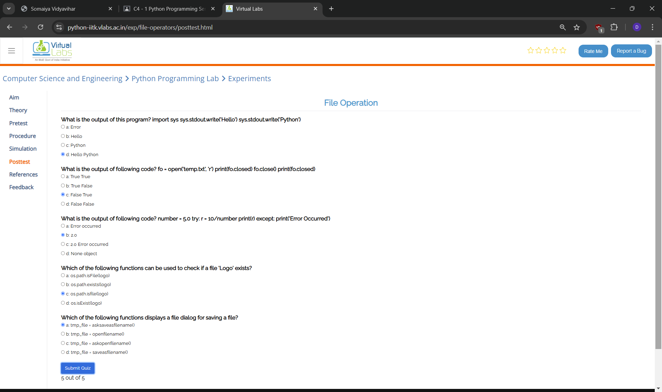

1. Write a program that prompts the user for a file name and then reads and prints the contents of the requested file in the upper case.

file_name = input("Enter a File Name: ")  
with open(f"{file_name}.txt", "r") as f:

print(f.read().upper())

**Date: _____________ Signature of faculty in-charge**